Engineering Brightness QC and Troubleshooting Guide

1. Visual inspection
   1. Solar panel

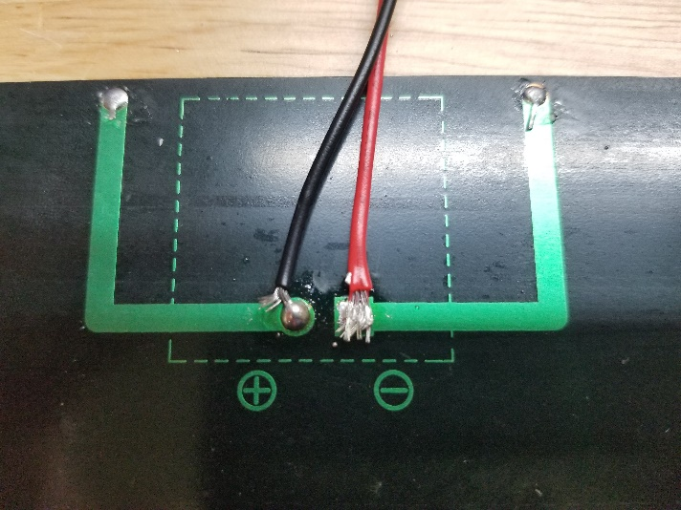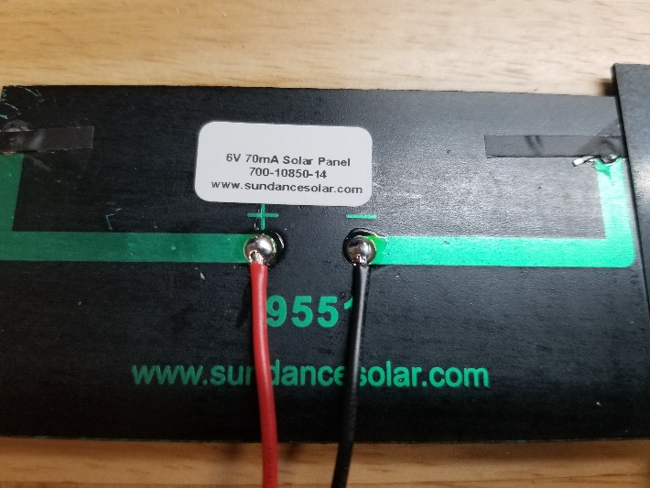

Incorrect Polarity

Frayed Wires

Too Little Solder

Correct Polarity

Solid wires

* 1. Battery charging board

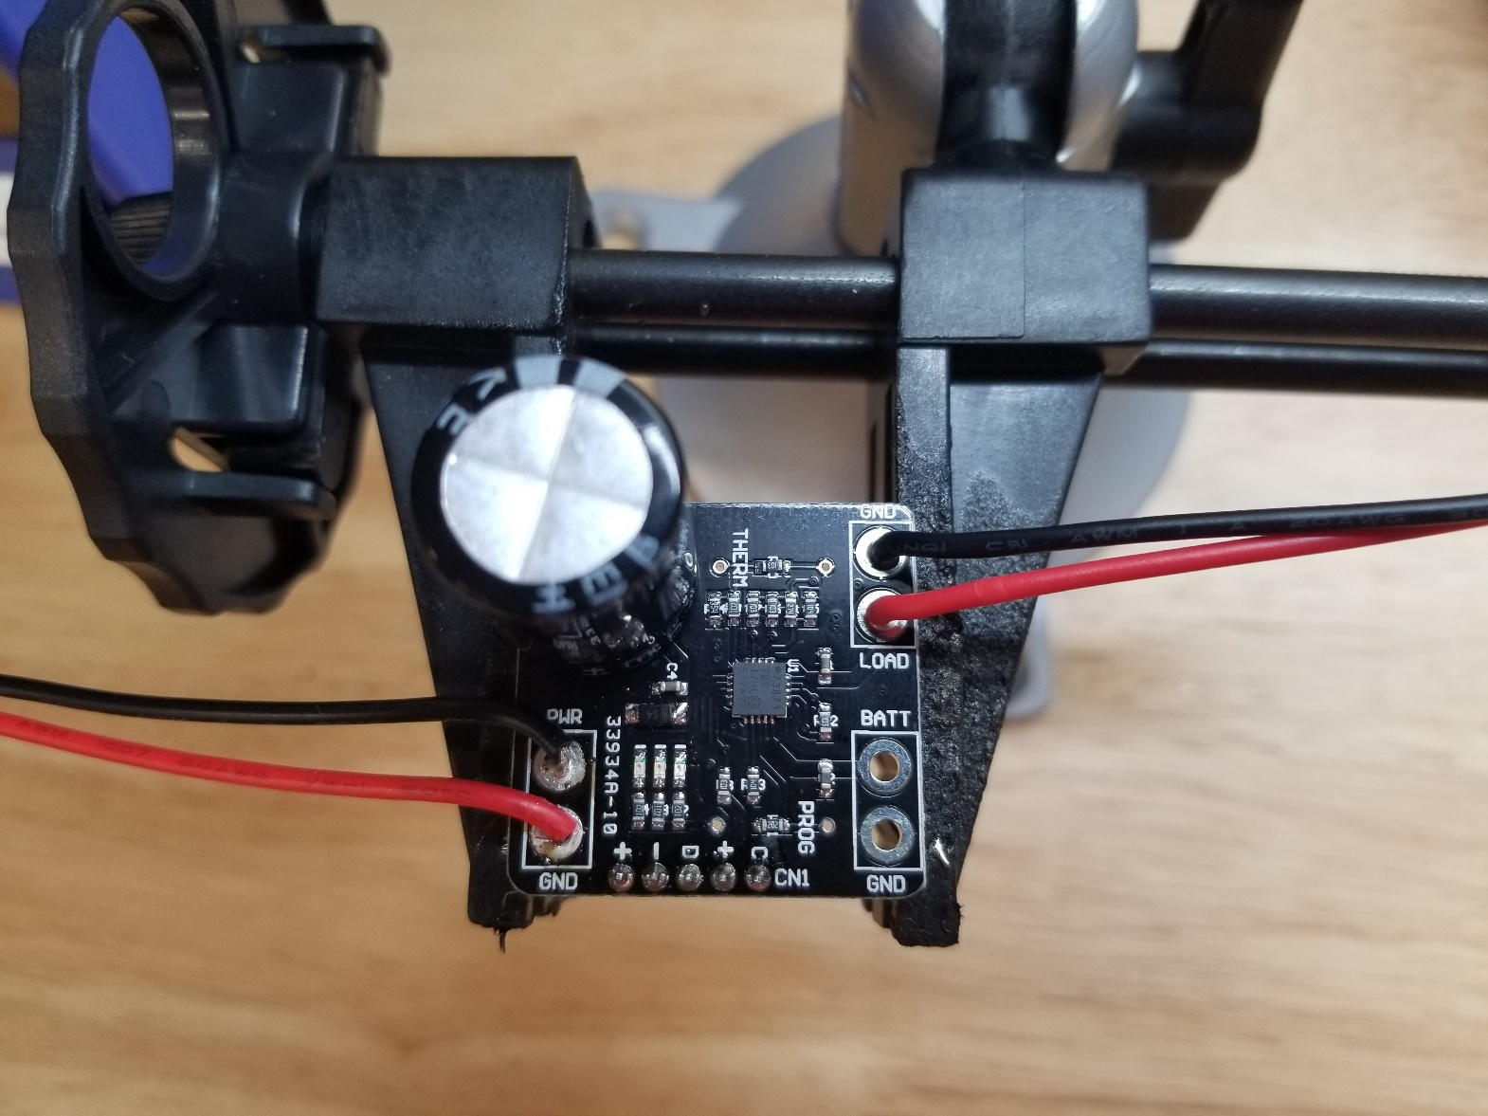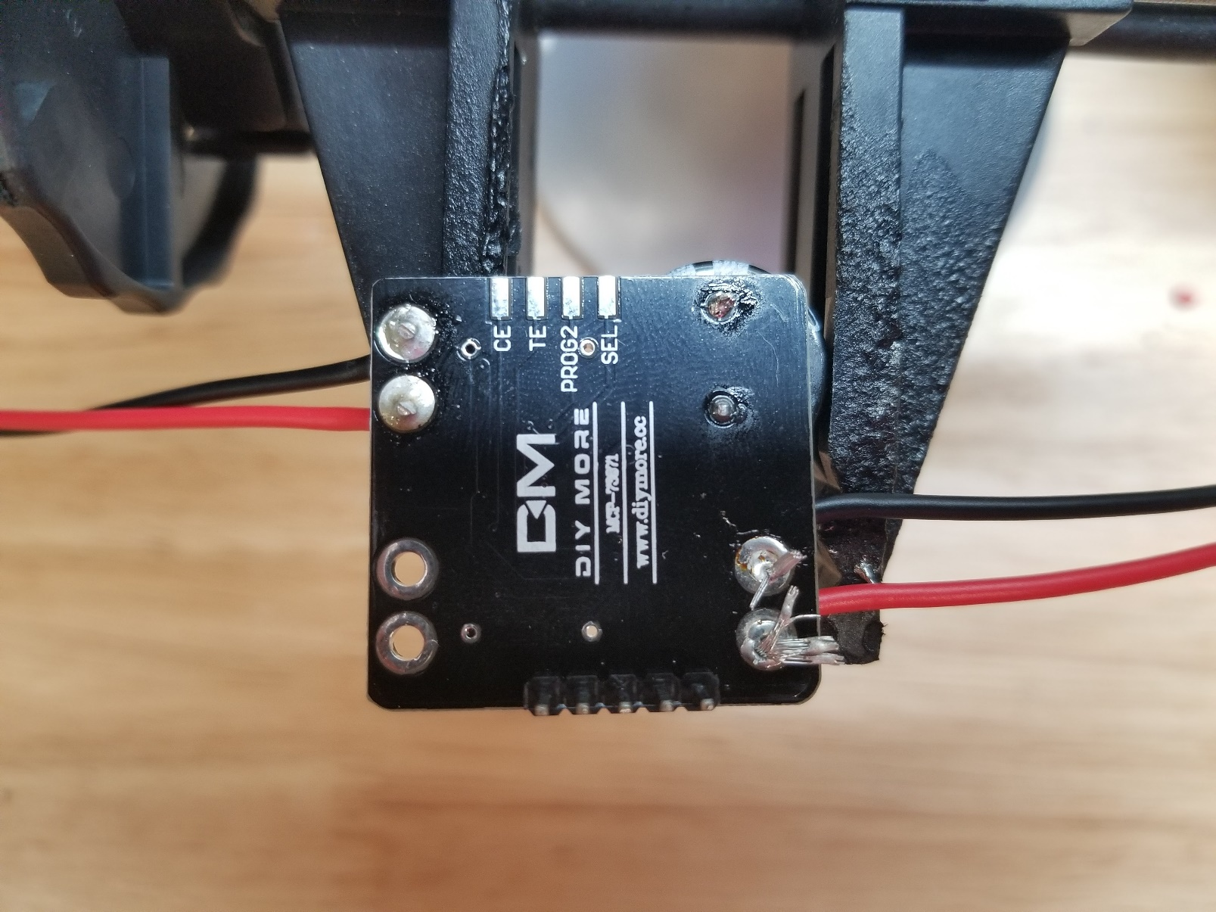

Wires long and frayed

Too little solder

Incorrect Polarity

Wires short and trimmed

Correct Polarity

* 1. LED Driver

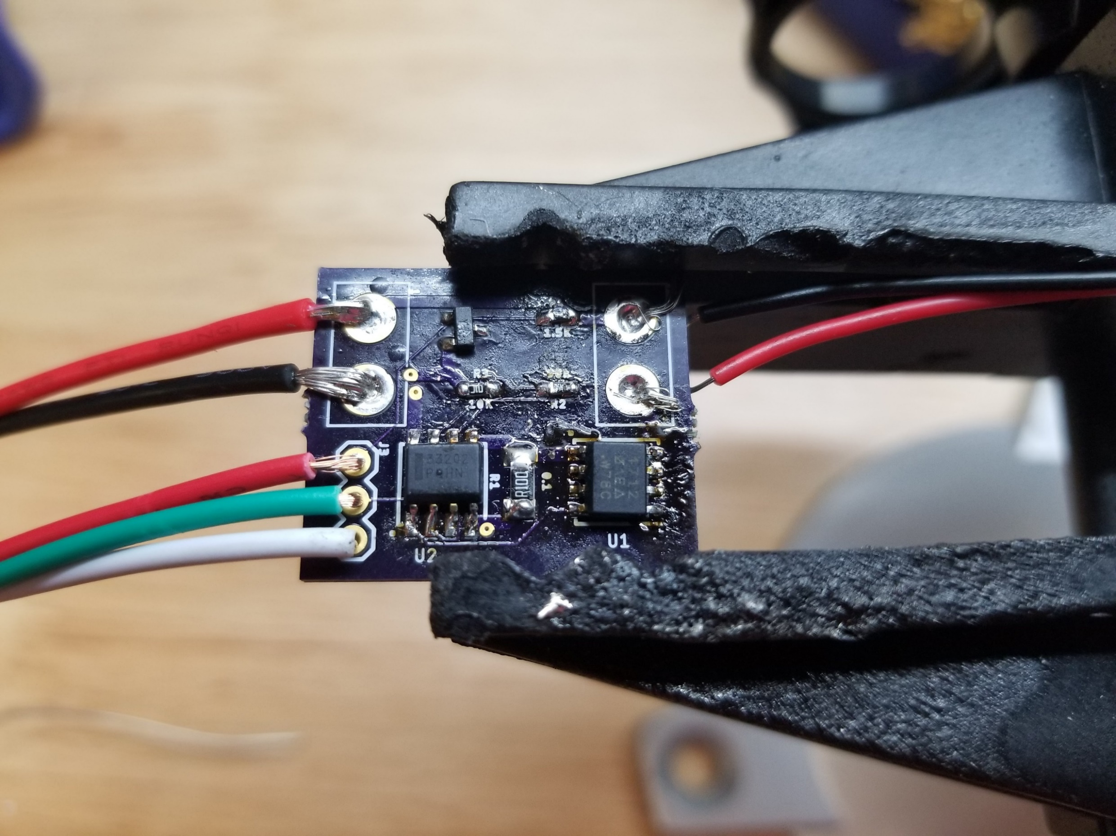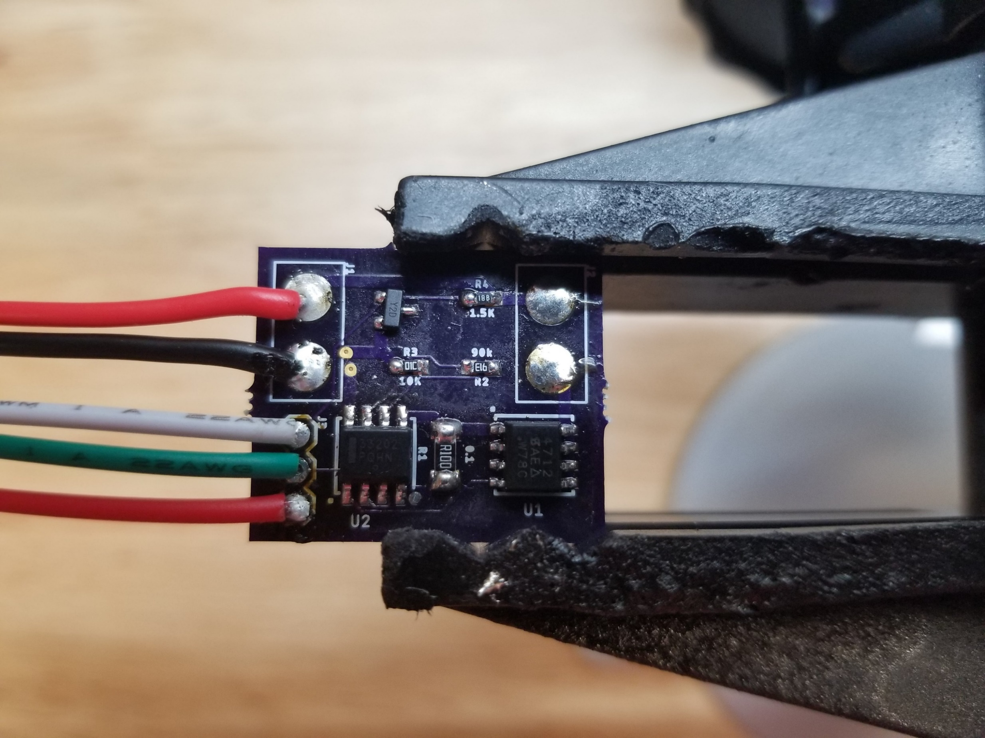

Wires too long

Not enough solder

Correct Length

Correct Polarity

Wrong Polarity

Flux residue

* 1. LED daughterboard

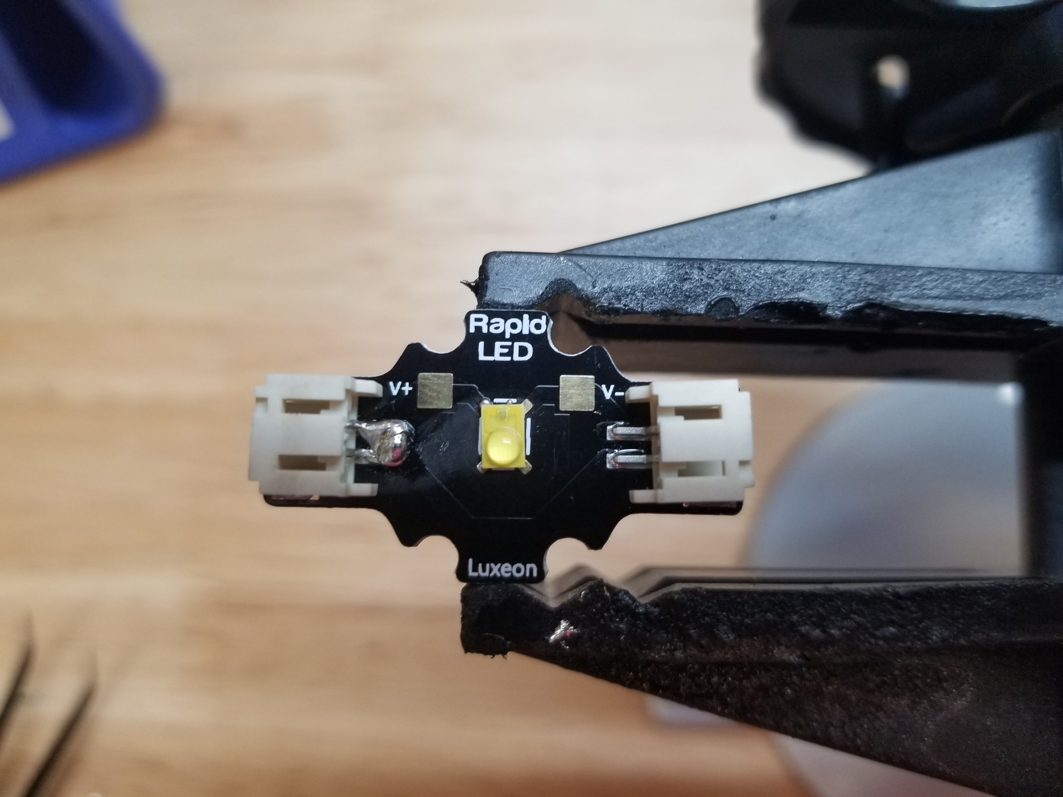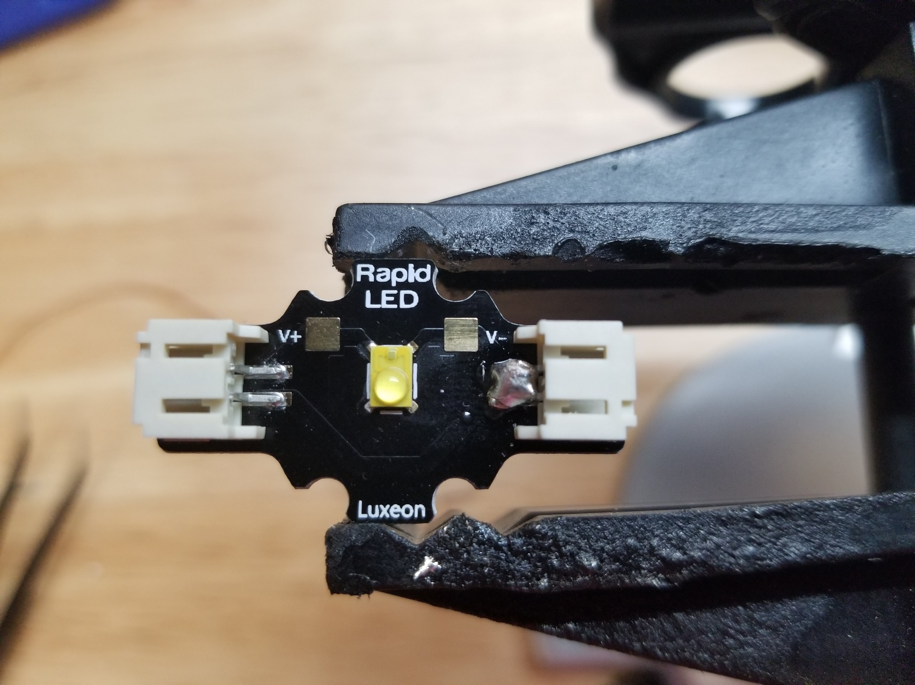

Good solder joint

Cold solder joint

1. Electrical Tests
   1. Connect a voltmeter to the solar panel, and place outside. The voltmeter should read approximately 6V in direct sunlight, and slightly less when dimly lit.
   2. Remove the battery from its holder, and measure its voltage. It should read between 3.2V when fully discharged and 4.2V when fully charged.
   3. Set the power supply to 6V at 1.5A and enable the output. Place the battery in its holder, and connect the battery holder to the charging board. Connect the power supply to the charging board input (where the solar panel would normally go). Depending on the state of the battery, either the “charging” LED or the “done charging” LED will be lit. Check that at least one is illuminated.
   4. Disconnect the power supply from the charging board and connect the solar panel in its place. At least one LED should be lit when in sunlight.
   5. Set the power supply to 5V at 1A, enable the output, and connect the LED. It should illuminate.
   6. Set the power supply to 5V at 1A and enable the output. Connect the LED to the output of the purple LED driver. Connect the input of the LED driver to the power supply. As the potentiometer is turned clockwise, the LED should illuminate and get brighter.
   7. As the potentiometer is turned counterclockwise, the LED should dim and eventually turn off.
   8. Connect the output of the black charging board to the input of the purple LED driver, and connect the battery to the black charging board. The LED should dim as the knob is turned.

Troubleshooting Guide:

1. 1. If there is no voltage on the solar panel or the voltage exceeds 7V, the panel is faulty.
   2. If the battery voltage is below 3.2V, charge it in the lithium ion battery charger until fully charged. If the battery voltage is above 4.2V, place it in a lantern and fully discharge the battery, and then fully charge it in the battery charger. If this occurs across multiple batteries contact the seller, they may have had a bad batch.
   3. If a status LED fails to illuminate when the charging board is connected to the power supply:
      1. Make sure the power supply output is enabled and set to 5V at 1A.
      2. Check that the capacitor polarity is correct.
      3. Check that the connector polarity is correct.
      4. Check that the battery is connected.
      5. Try replacing the charging board with one that is known to work.
   4. If a status LED fails to illuminate when the charging board is connected to the solar panel:
      1. Check the connector polarity.
      2. Check that the battery is connected.
      3. Try replacing the solar panel with one that is known to work.
      4. Try replacing the charging board with one that is known to work.
   5. If the LED fails to illuminate when connected to the power supply:
      1. Make sure the power supply output is enabled and set to 5V at 1A.
      2. Check the LED polarity.
      3. Confirm that one connector has been shorted out.
   6. If the LED driver fails to dim the LED when connected to the power supply:
      1. Make sure the power supply output is enabled and set to 5V at 1A.
      2. Check connector polarity.
      3. Confirm that all components are installed on the LED driver.
      4. Check the orientation of the ICs on the circuit board. The stripe on the OpAmp should be facing the white dot next to either U2 or OA, and the dot on the MOSFET should be facing the white dot next to either U1 or MF.
      5. Clean any flux residue off the board with isopropyl alcohol. Clean the space between the legs of the ICs especially well.
      6. Check for any cold solder joints or unsoldered pins on the board, and reflow the joints if necessary.
      7. Desolder the small 0603 resistors and replace them with new components. It’s possible that the wrong value of resistor was installed.
   7. If the LED gets brighter as the potentiometer is turned counterclockwise and get dimmer as the potentiometer is turned clockwise:
      1. Reverse the polarity of the potentiometer
   8. If the LED doesn’t illuminate when powered from the battery:
      1. Confirm that the potentiometer is turned on.
      2. Charge the battery using the lithium ion battery charger, and try again when it is charged.
      3. Replace the charging board with one that is known to work.
      4. Replace the LED driver with one that is known to work.